Dharmendrasinhji Arts College, Rajkot
Dr. Yagnik Road, Ph./Fax No. (0281) – 2465632
Govt. Of Gujarat
(Affiliated with Saurashtra University)

7.1.7 The Institution has disabled-friendly, barrier free environment
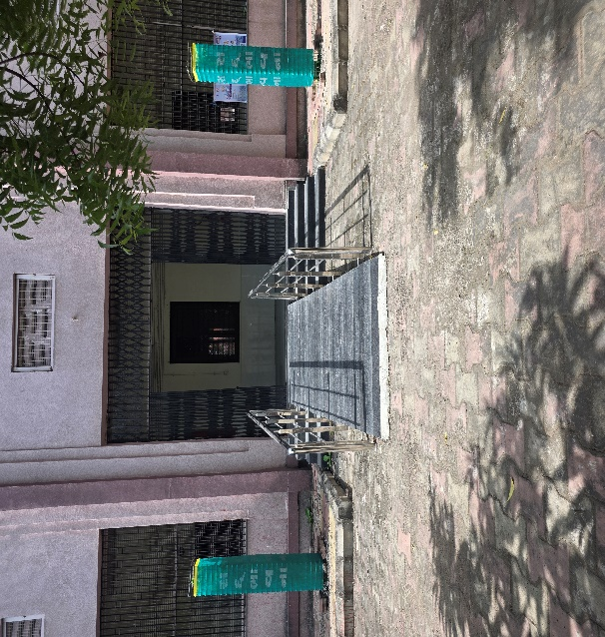
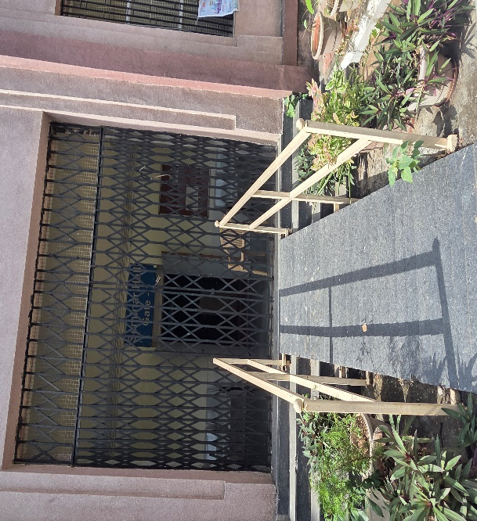
Ramps for Easy Access to Classrooms

Disabled-friendly washrooms
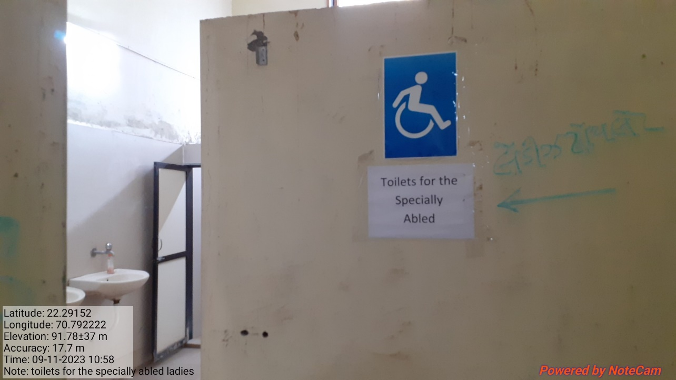

sign Posts
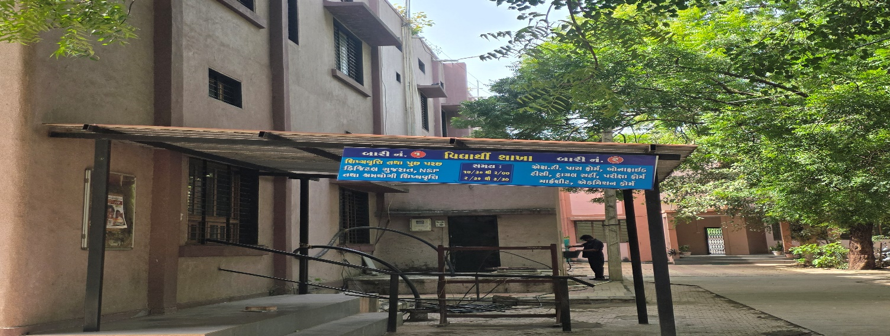
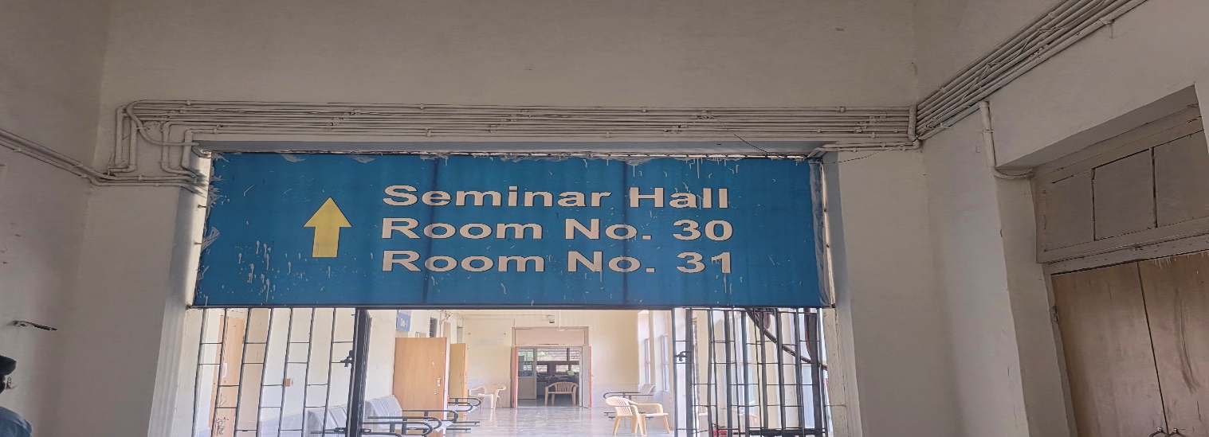

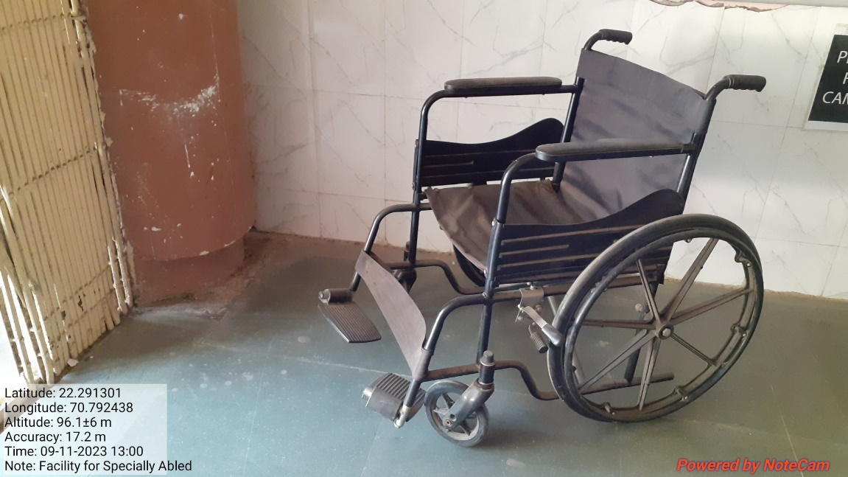
Mechanised equipment and facilities for disabled students

Human Assistance
